Project Design Phase
Solution Architecture

Date | 03 October 2026
Team ID | SWTID-2026-6867
Project Name | Streamlining IT Procurement: Automating Standard Laptop Orders with Flow Designer
Maximum Marks | 4 Marks

Solution Architecture:
Solution architecture is a complex process – with many sub-processes – that bridges the gap between business problems and technology solutions. Its goals are to:
- Find the best tech solution to solve existing business problems.
- Describe the structure, characteristics, behavior, and other aspects of the software to project stakeholders.
- Define features, development phases, and solution requirements.
- Provide specifications according to which the solution is defined, managed, and delivered.
Solution Architecture Diagram:
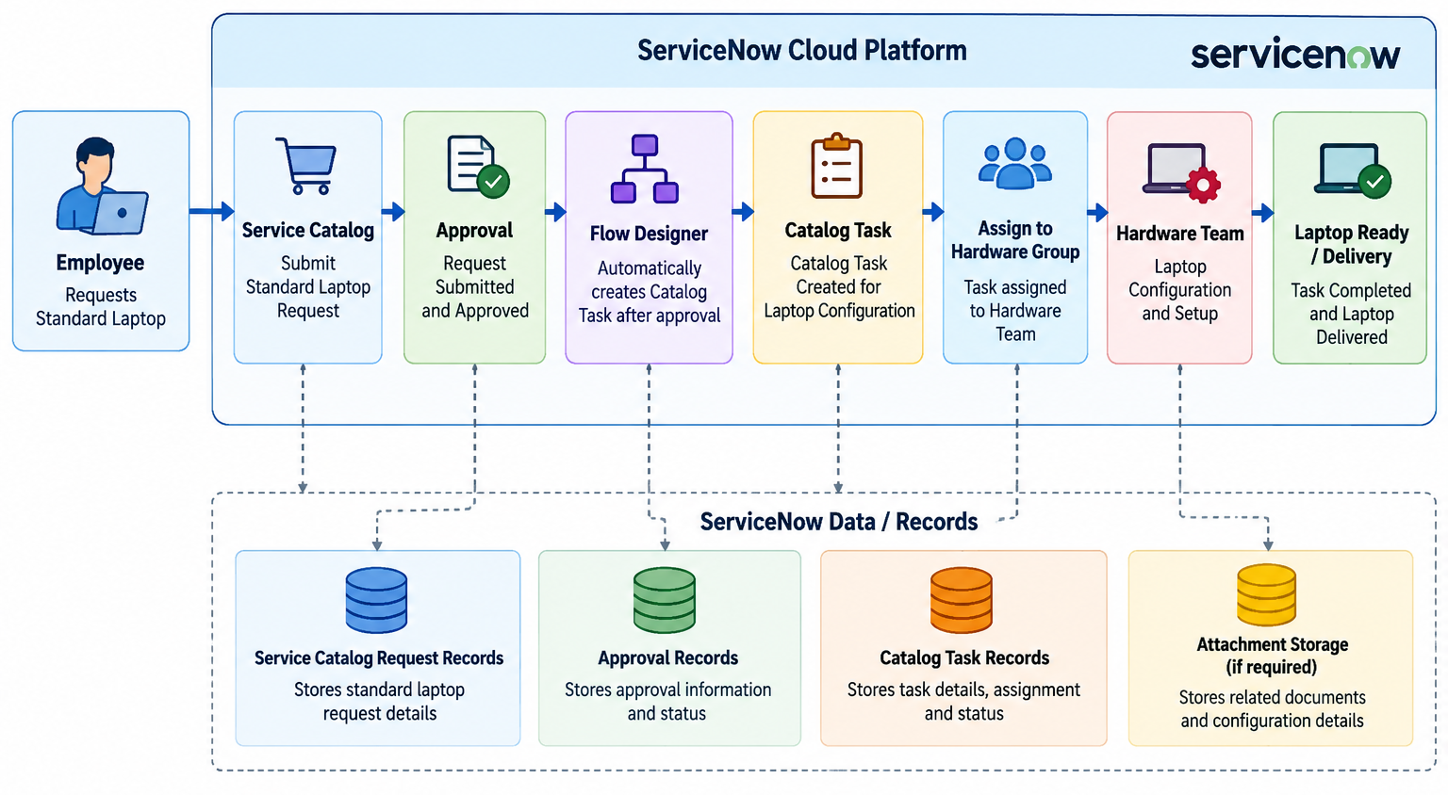
Figure 1: Solution architecture and data flow of the standard laptop procurement automation
References:
1. ServiceNow Flow Designer – https://www.servicenow.com/in/products/platform-flow-designer.html
2. ServiceNow Service Catalog – https://www.servicenow.com/products/it-service-automation-applications/service-catalog.html
3. ServiceNow Developers – https://developer.servicenow.com/

